AI Agent for Documentation and Summation
(Other Items)
Version 1.0
Team Members:
Abhisar Anand, Ali Mutlak, Brayan Cano, Dhyan Patel, Myles Edwards, Shar Min

Resources & Technology

Resources:

- Android Device for app testing and recording audio
- Visual Studio Code for dashboard
- Android Studio for Mobile App
- Github for version control
- Jira for Scrum
- Discord/Outlook for team communication
- PC with a powerful GPU to run our programs locally (internal server)

Technology:

- Java/Kotlin - App Development
- PostgreSQL & PgAdmin – Database
- Git - Version Control
- OpenAI Whisper - Audio to Text Transcription

Software Verification Plan
Verification Team Lead: Abhisar Anand
Every team member will be responsible for integrating unit tests within their code. Code reviews will be performed with the completion of sprints.

The test case for each portion of our project will be defined as a sprint, with its own expected completion day and results summary.

Verification Objectives:

Web Dashboard –

- Ensure authentication process controls access
- Visualization format correctness between varying devices
- All connections between core components (dashboard, app, and AI) are secure

Android App –

- Stability and user navigation
- API synchronization (speech to text, and OCR)
- Offline behavior is handled
- OCR performs within expected accuracy (CER < 1% on clean text, < 3% otherwise)

AI/ML Module –

- Model accuracy and recall (F1 score ≥ 0.8)
- Consistency of summations
- Accurate speech attribution

Database –

- HIPPA Compliance with text storage
- Temporary audio storage
- Data Integrity

Stretch Requirements

- AI Summation processing before a visit is complete so that all participants may be handed a physical copy of the report.
- Multilingual support in both the OCR and speech to text transcriptions.
- Entirely self-contained.
- Statistics and analysis reports derived from the transcription and AI.
- Real time captions of audio to be displayed on the dashboard.

Estimated Hours to Complete Project

The project will likely take us the full scholarly year to complete. These estimates only approximate the number of hours spent on individual tasks, rounded together. They do not include meetings, in-person events, etc. It might be safe to assume an added hour for each week of work.
Hours per Day by Member (including weekends) ≈ 1 hour
Total per Week ≈ 42 hours
Total for Fall Semester ≈ 115 days * 6 hours = 690 hours
Total for Spring Semester ≈ 121 days * 6 hours = 726 hours

Total ≈ 1,416 hours

Project Feasibility

The team has collectively agreed that this project is feasible, in consideration of the timeframe and estimated hours.

Penpot Wireframe

Android App:

Interactive Link: https://design.penpot.app/#/view?file-id=c88a5a55-d913-809f-8006-eda79cc4887d&page-id=c88a5a55-d913-809f-8006-eda79cc4887e&section=interactions&frame-id=3fe8cc65-d304-803c-8006-eda7dbc2febb&index=0&share-id=aadbbc88-0e4c-80b8-8006-edcf116b7a65
Clicking the Vinyl record symbol will lead the user to the recording page.
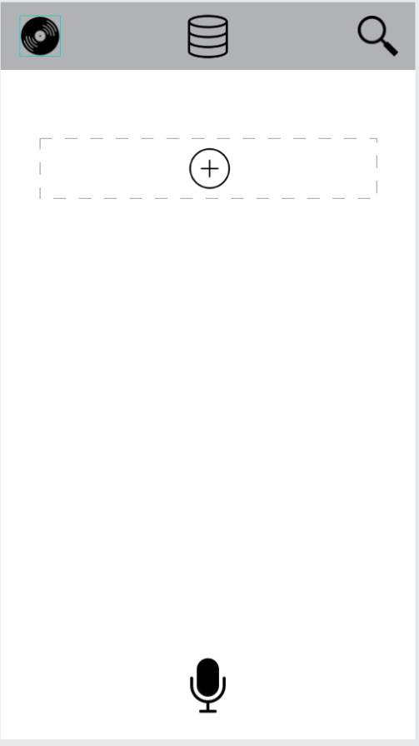

Clicking the plus icon on the recording page allows the user to add a participant in the coming recording/conversation.
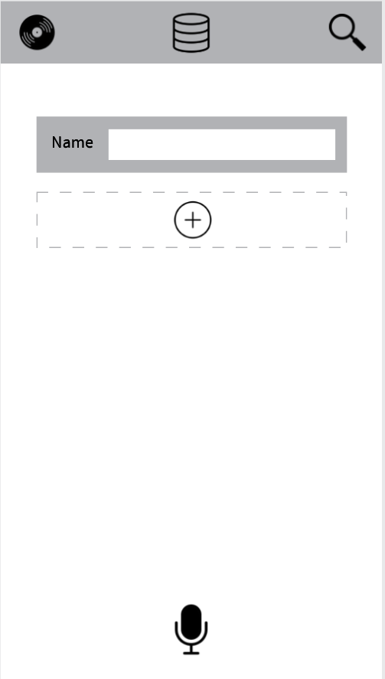

Clicking the Magnifying glass icon will open the page for taking pictures of documents to be processed by OCR. 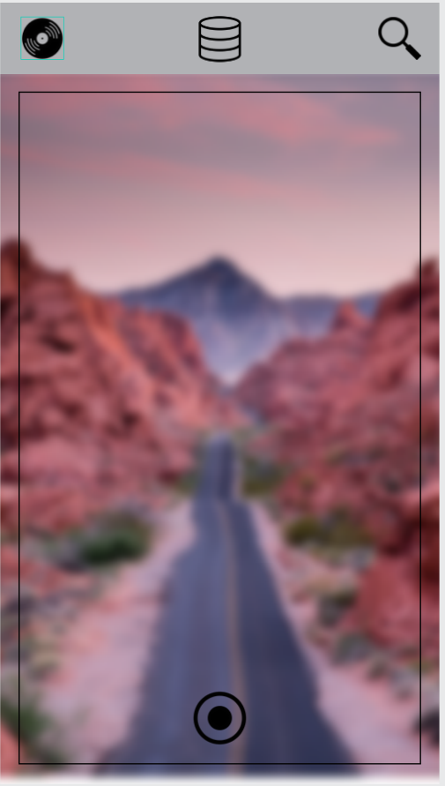
After taking a picture, the page will request for a name, before processing through OCR.
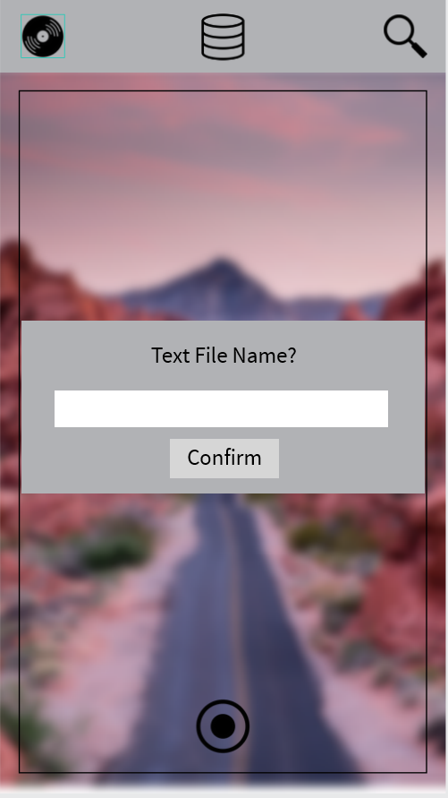

Clicking the Storage Icon in the middle of the header, will open a page that gives the user two options, in order to view what they have stored/processed.
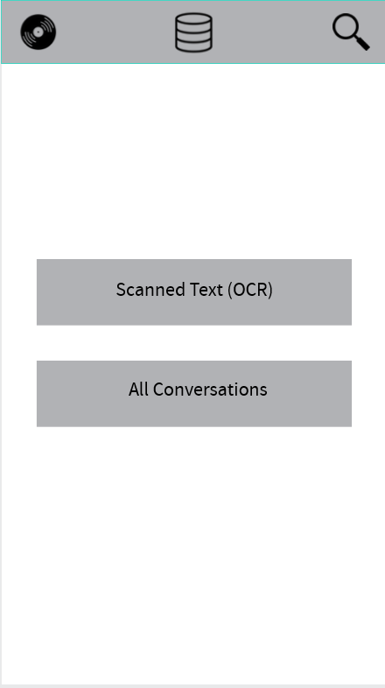

Clicking the “Scanned Text” button, will lead the user to a page of tables containing all the pictures OCR processed.
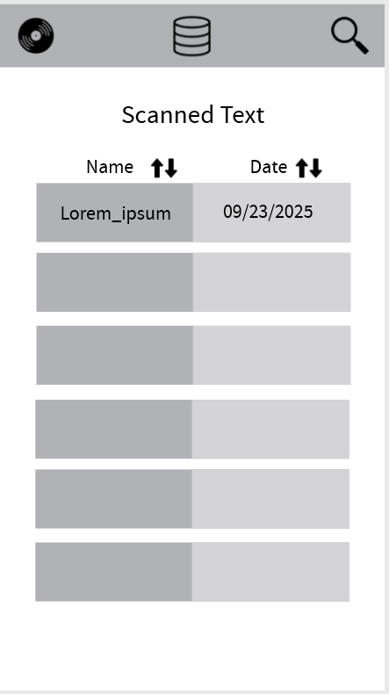

Clicking on “All Conversations” leads the user to a table displaying all the recorded conversations that have been processed.
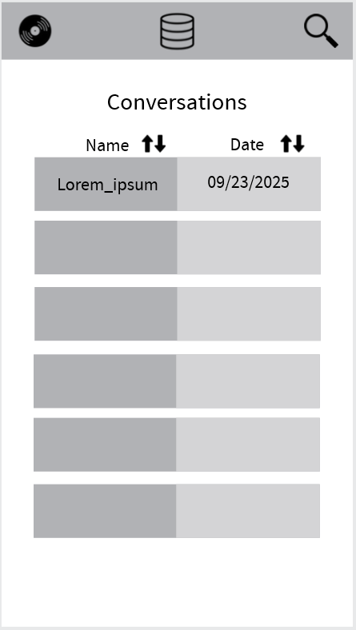

Clicking on the desired row in the table for Conversations, will lead to a details page that allows the user to view more information in regard to that conversation.
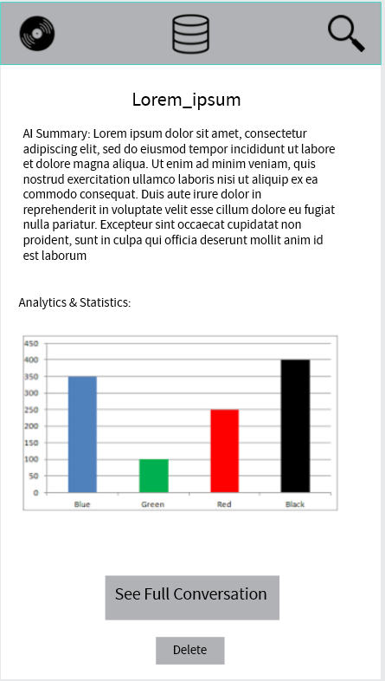

Clicking a row desired in the table for Scanned Text, will display a page that allows the user to view more details on the text derived by OCR, and the photo.
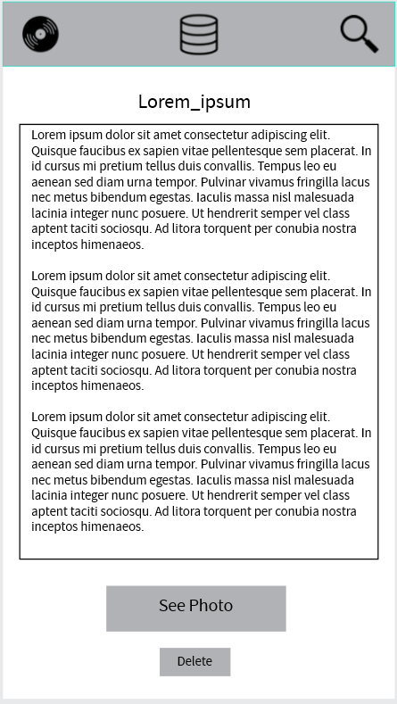

Web-Based Dashboard:

Interactive Link: https://design.penpot.app/#/view?file-id=c88a5a55-d913-809f-8006-eda79cc4887d&page-id=3fe8cc65-d304-803c-8006-eda7ab979646&section=interactions&frame-id=3fe8cc65-d304-803c-8006-edc1d4c1ec74&index=0&share-id=c88a5a55-d913-809f-8006-edcd9d4b3faf

This is the welcome screen, requiring login.
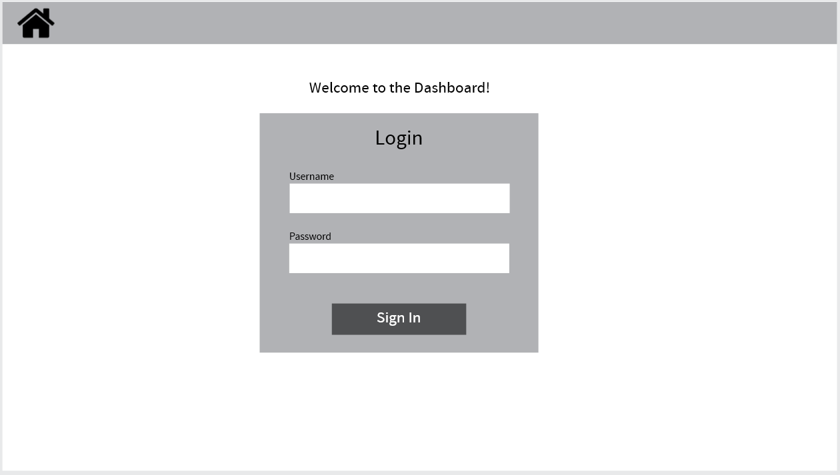

The elipses in the top right corner will show locations to where the user may navigate.
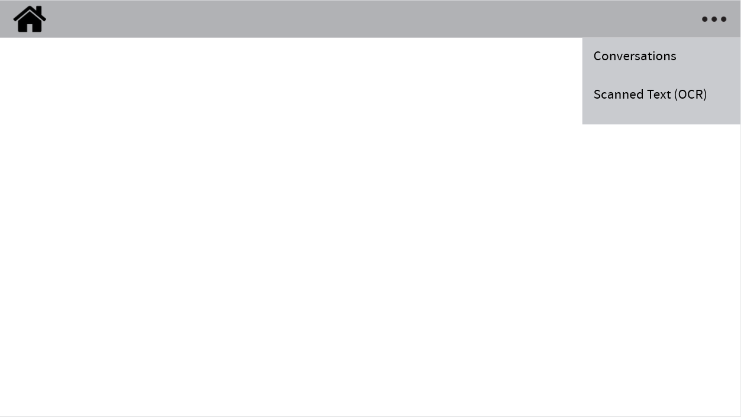
The user may view all conversations recorded and processed.
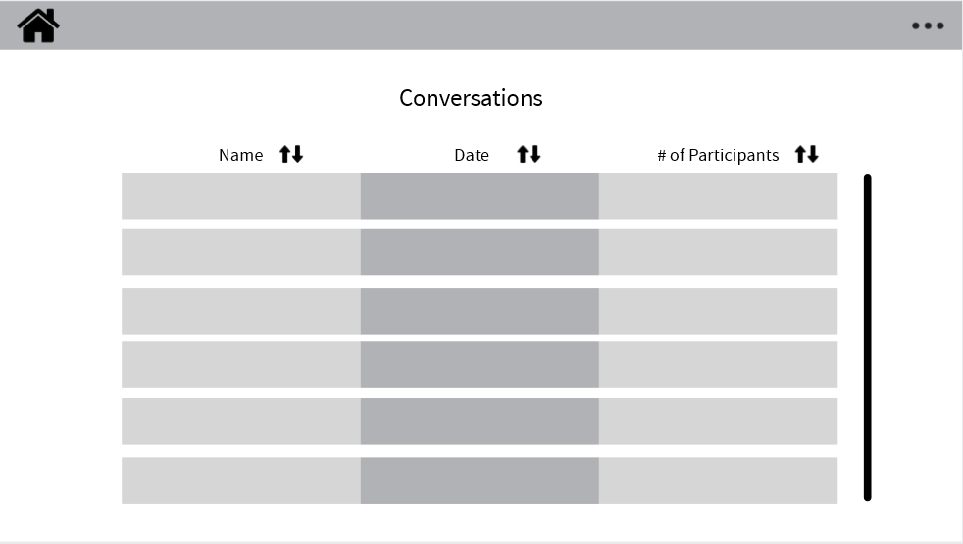

The user may view all Scanned Text processed by OCR
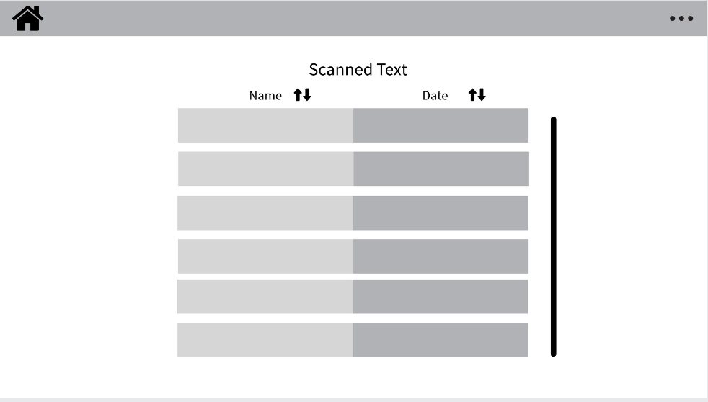

This is the details page for a specific conversation
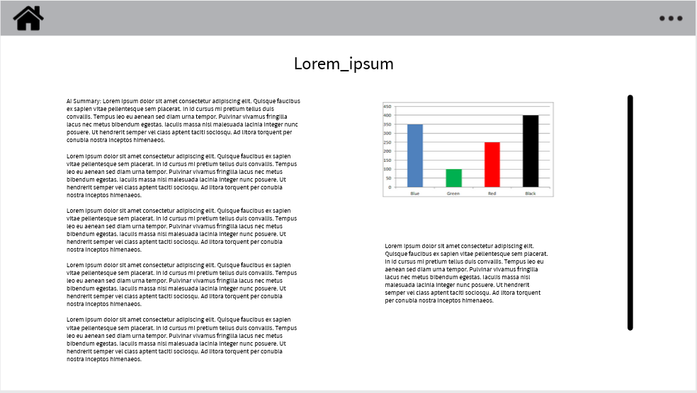

This is the details page for a specific OCR processed photo.
